**Government Polytechnic,Pune**

(An Autonomous Institute of Government of Maharashtra)



**A**

**MICRO PROJECT REPORT**

**ON**

**“Random Question Paper Generator”**

**PRESENTED BY**

1. **Himanshu Sangale (1807020)**
2. **Akshay Ghuge (1807018)**
3. **Vikas Hake (1807019)**

**Submitted To**

**GOVERNMENT POLYTECHNIC, PUNE**

**OF**

**SECOND YEAR DIPLOMA IN**

**INFORMATION TECHNOLOGY ENGINEERING**

**2018-19**

**Government Polytechnic,Pune**

**(An Autonomous Institute of Government of Maharashtra)**



***CERTIFICATE***

**This is to certify that**

1. **Himanshu Sangale (1807020)**
2. **Akshay Ghuge (1807018)**
3. **Vikas Hake (1807019)**

**Has completed the necessary micro project work and prepared the report on**

**“Random Question Paper Generator”**

**In a satisfactory manner as a partial fulfillment of requirement of the**

**SECOND YEAR DIPLOMA**

**IN**

**INFORMATION TECHNOLOGY**

**FOR THE ACADEMIC YEAR**

**2018-2019**

**Guided by:**

**Smt. H F Khan**

**Contents:**

1. Introduction
2. Explanation
3. Problem statement
4. Solution
5. Conclusion

**Introduction:**

The following project has been developed using Codeblocks. In this micro project we have created a program that generated question papers by randomly choosing the questions to be displayed.

This project has been developed using Object Oriented language C++. Various concepts of C++ are used to give this project the required perfection.

**Problem statement:**

Generate Question paper from Question Bank (Use random question generator).

**Explanation:**

This program’s main aim is to generate Question papers by randomly choosing the questions. The questions which are included in the project are imported from an external text file using the concept of file handling.

To choose a random question, first a random number is generated using the random function rand() and srand() is used to provide the seed for the rand() function. The function then generates any random number but the number needs to be between zero and the maximum number of question available to choose from. Then the random number generated is checked for repetition, if the number is used previously of generated previously then rand() function is again invoked to generate another random number. The if the number passes the check then it is passes on to the generator function which then reads the external text file that contains the question to be included in the program. The random number is then taken as a line number of the text file from which the question needs to be extracted. Suppose if the random number generated is ‘n’ then the question present at nth line of the text document (“Questions.txt”)will be chosen to display by the function. In this way bunch of question are selected at random to form a question paper.

After the execution of the whole program, the generated question paper is saved into an external text file named “output.txt”, this is done to enable user to directly take printout of the output in the same format in which the output is displayed.

Thus, by changing the input text file and making some minor changes to the code, this program can be used to generate number of question papers for any subject specified.

**Output:**

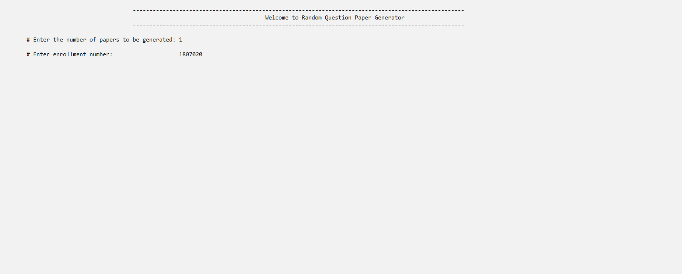

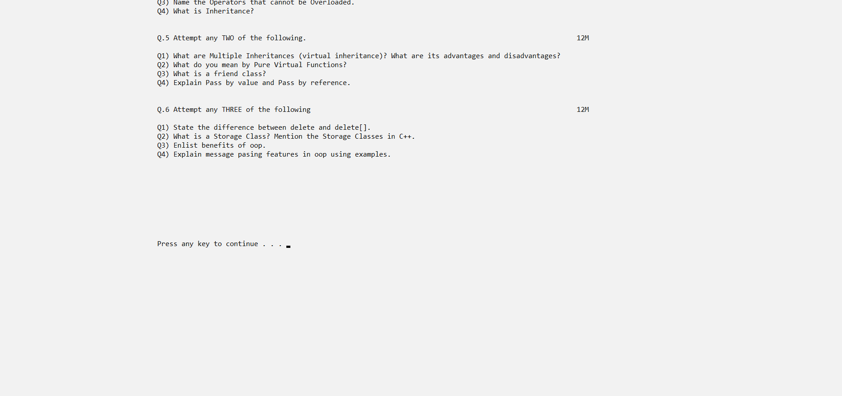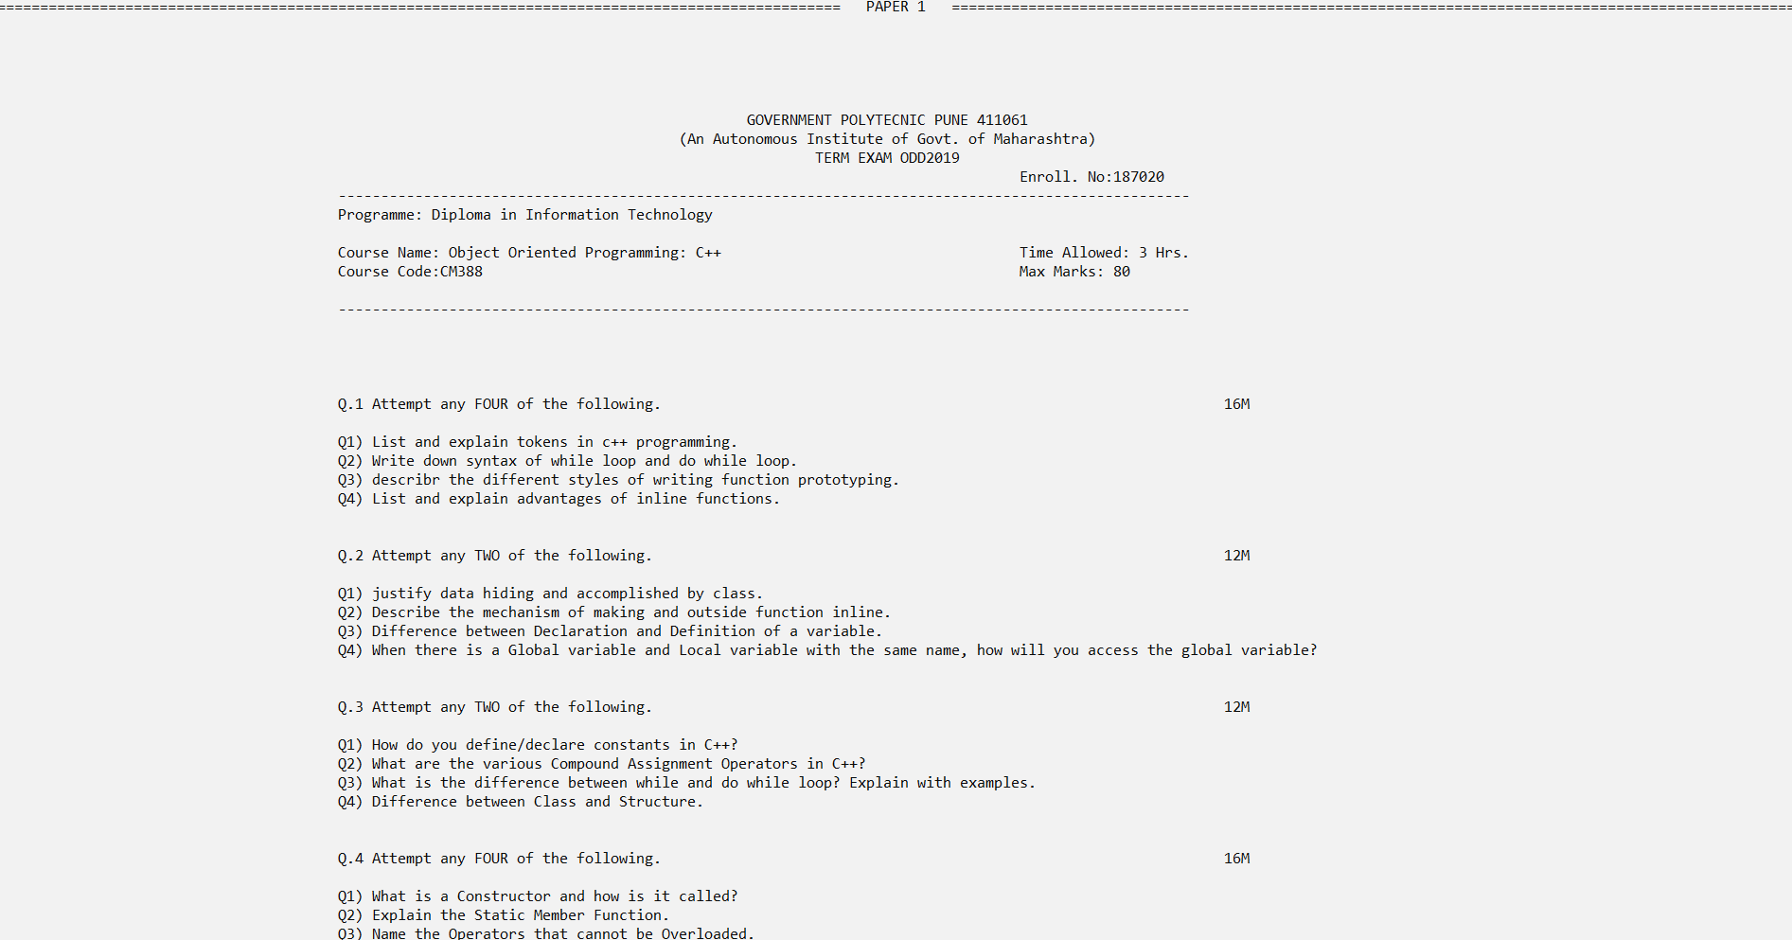

**Conclusion:**

Thus we have used various concepts of Cpp to create a micro project on topic Random Question generator.

Sign.